**RESUME** 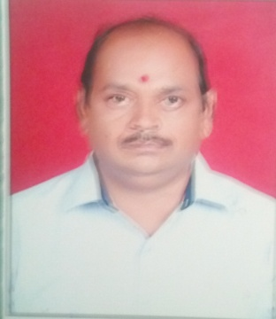

**1. Personal Information:**

**Full Name – MANOJ** PURSHOTTAM PATIL

**Date of Birth –** 29TH NOV. 1970

**Designation –** INSTRUCTOR CARPENTER

**Email Address –** manojpatil291170@gmail.com

**2. Academic Profile:**

|  |  |  |  |  |  |  |
| --- | --- | --- | --- | --- | --- | --- |
| **Sr. No.** | **Education** | **University** | **Percentage** | **Passing Year** | **Specialization** | **Special Honour** |
| 1 | I.T.I | Delhi board | 73.00 | 1991 | carpenter | Dist. |
| 2 | A.T.I | Saion Mumbai | 76.00 | 1995 | carpenter | Dist. |
| 3 | B.A. | Pune university | 62.00 | 1994 | Marathi |  |

**3. Experience Details: 15 Years.**

|  |  |  |  |  |
| --- | --- | --- | --- | --- |
| **Sr. No.** | **Organization / Institute** | **Designation** | **Working Period** | **Discipline** |
| 1 | Government College of Engineering, Jalgaon | Instructor Carpenter | 02/06/2015 to till date | Workshop |
| 2 | Government Polytechnic Nashik | Instructor Carpenter | 06/06/2011 to 01/06/2015 | Workshop |
| 3 | Government College of Engineering, Jalgaon | Instructor Carpenter | 02/06/2006 to 08/06/2004 | Workshop |
| 4 | Government Polytechnic Dhule | Instructor Carpenter | 16/08/2004 to 16/8/2006 | Workshop |
| 5 | Government Polytechnic Jalgoan | Instructor Carpenter | 24/01/2000 to 16/8/2004 | Workshop |

1. **STTP**

|  |  |  |  |  |
| --- | --- | --- | --- | --- |
| **Sr. no.** | **Title** | **Details of organizing body** | **Venue** | **Duration** |
| **1** | **Recent trends in W/S Techo.** | **TEQIP** | Government College of Engineering, Jalgaon | **09/01/2017 to 13/01/2017** |